CSF, OFAC’s SDN, and Data Sovereignty

By Abraham Cain

When it comes to protecting your digital assets overseas, there are a few things you need to consider. This briefing covers three sets of recommendations/considerations for protecting your data when it needs to leave the borders of the U.S. The first will be based off of the NIST Cybersecurity Framework (NIST CSF). The second deals with data sovereignty and its affect on your data. The last will be in regard to the Office of Foreign Assets Control (OFAC)'s specially designated nationals and blocked persons list.

Very similar to securing digital assets in the U.S., following a security framework or making use of one to form your information security management system (ISMS) will be a great defense. I would recommend following and adapting where necessary, the NIST CSF. The core components of the framework are:

* Identify
* Protect
* Detect
* Respond
* Recover. (NIST, 2021)

*Figure 1. NIST CSF Core Breakdown (NIST, 2021)*

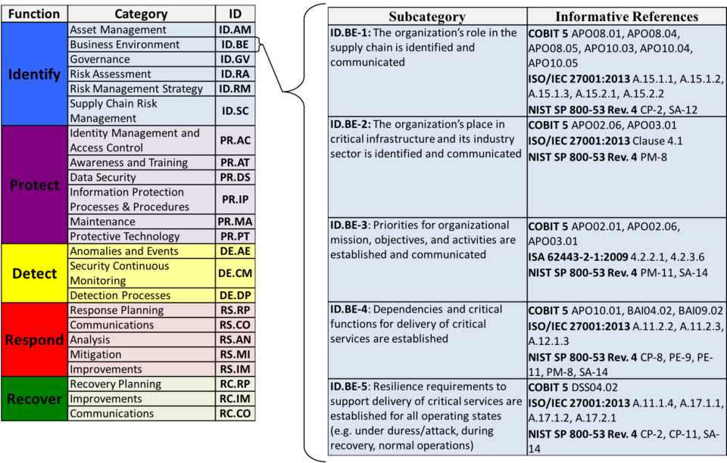

These core components are broken down into categories and subcategories as shown in figure 1 from NIST's website (2021). This framework gives security departments a guide to setting up the People, Policies, Processes, and Technologies to create a successful security program.

Next, we turn to a more specific problem to address with overseas asset protection: data sovereignty. If your company has technology, trade secrets, or anything else of value to competitors, you may have to be careful of which countries you allow it to enter. Oracle (2021), defines data sovereignty as the idea that the country in which data originates will have affect on it with their laws and regulations. An example of this would be medical data recorded about a patient in a US hospital having to be subject to HIPAA compliance because HIPAA is a law in the united states governing the protection and confidentiality of personal health information (PHI). Where this comes into play with asset protection is considering that some foreign countries may have right to steal your intellectual property and use it as their own or breach your privacy if your data is created or hosted in their country.

In addition to data sovereignty, you should consider the OFAC's specially designated nationals and blocked persons list. This is a list of mostly foreign people or organizations that it is illegal for US citizens to do business with. This affects your business and assets because if you are looking to open up shop or sell to consumers overseas, you are responsible for ensuring that none of your customers fall on that list. The punishment according to Comply Advantage (2021) can be up to $20 million and up to 30 years in prison. Pretty serious punishments considering the average sentence for 1st degree murder is 17.3 years (William, 2020).

In summary, there are three main points that you should take away from this briefing:

* Implementing NIST CSF will help you build your security program up in general.
* Considering foreign nations' relationships with the US and US companies is crucial to understanding your risk for intellectual property theft or espionage.
* Checking to ensure that none of your prospective clients/customers are on the OFAC's SDN list will help keep you safe from fines and jail time.

Combining these three strategy points will help you mitigate risks associated with digital asset theft when operating overseas.

**References**

Comply Advantage. (2021). *Consequences of OFAC sanctions violations*. <https://complyadvantage.com/knowledgebase/what-are-sanctions/consequences-ofac-sanctions-violations/>

NIST. (2021, May 14). *An introduction to the components of the framework*. Retrieved August 4, 2021, from <https://www.nist.gov/cyberframework/online-learning/components-framework>

NIST. (2021). [Diagram]. <https://www.nist.gov/cyberframework/online-learning/components-framework>

Oracle. (2021). *What is data sovereignty?* <https://www.oracle.com/security/saas-security/data-sovereignty/>

William. (2020, October 15). *What are the average and maximum jail times served?* Blackford & Flohr LLC. Retrieved August 3, 2021, from <https://bflawmd.com/average-maximum-jail-time-common-crimes/>